**Lesson 3 Demo 12**

**Upgrade to the Latest Version of Kubernetes**



Steps to be followed:

1. Upgrading kubeadm to the latest version
2. Upgrading kubelet and kubectl to the latest version

**Step 1: Upgrading kubeadm to the latest version**

1. Use the following command to check the kubeadm upgrade plan:

***sudo*** ***kubeadm upgrade plan***

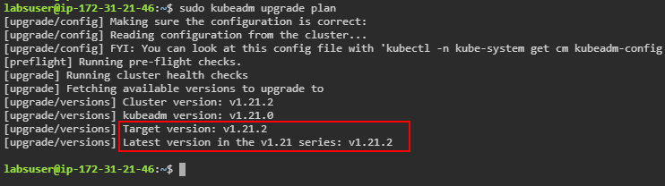

| **Note:** Notice that in our lab environment, **kubeadm version** is v1.21.0. |
| --- |

1. Run the following command to upgrade kubeadm to the latest version:

***sudo apt-mark unhold kubeadm && \***

***sudo apt-get update &&***

***sudo apt-get install -y kubeadm=1.21.2-00 && \***

***sudo apt-mark hold kubeadm***

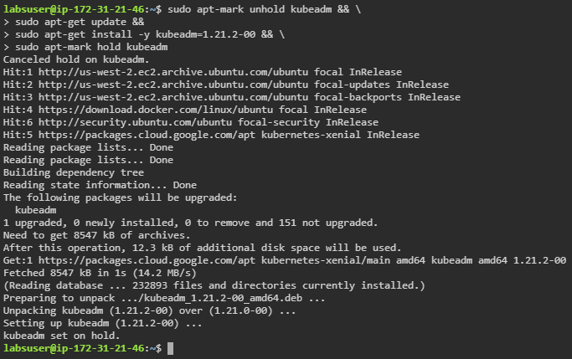

1. Check the kubeadm version

***kubeadm version -o yaml***

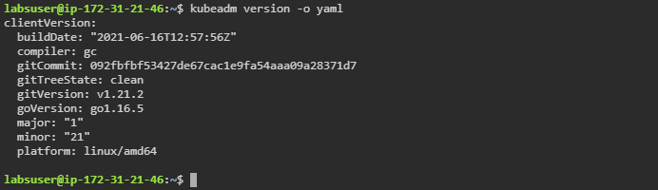

**Step 2: Upgrading kubelet and kubectl to the latest version**

1. On the **master** node, run the following command to install the latest version of kubelet and kubectl:

***sudo apt-mark unhold kubelet kubectl && \***

***sudo apt-get update &&***

***sudo apt-get install -y kubelet=1.21.2-00 kubectl=1.21.2-00 && \***

***sudo apt-mark hold kubelet kubectl***

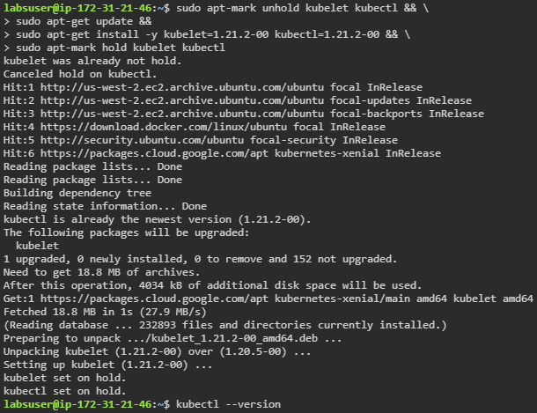



1. Check the kubectl version on the master node

***kubectl version -o yaml***

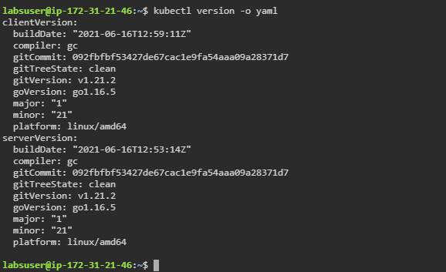

1. Click on **worker1** and **worker2** tabs in the lab to open them in new tabs

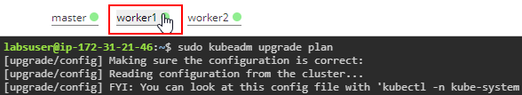

1. Check the kubelet version on **worker1** and **worker2** nodes

***kubelet --version***



